**estimation**

**Aims and Objectives:**

* To determine the percentage of chlorine in a sample with AgNO**3**.

**INTRODUCTION**

**CHEMICALS AND EQUIPMENT**

* AgNO**3**.
* Potassium chromate as indicator
* 250ml volumetric flask.
* Pipette.
* Burette.
* Retort stand.
* Conical flask.
* Electronic balance.
* Unknown sample.
* Measuring cylinder.

**PROCEDURE**

* A 0.1g of the unknown sample is weighed into a beaker. The weighed sample is dissolved with distilled water into a 250ml volumetric flask and topped to the mark.
* 50ml of the solution was pipette into a conical flask and 2ml of a 5% potassium chromate is added which turned the solution to yellow.
* This is titrated against the 0.1M AgNO**3** solution from the burette. A red precipitate signifies an end point.
* Procedure 2 and 3 is repeated for concordant values of the endpoint.

**TABLE OF VALUES**

|  |  |  |  |
| --- | --- | --- | --- |
| **Burette Reading/cm3** | **1** | **2** | **3** |
| **Final** | 10.40 | 20.90 | 31.50 |
| **Initial** | 0.00 | 10.40 | 20.90 |
| **Titre value** | 10.40 | 10.50 | 10.60 |

**CALCULATIONS**

Reactions:

Ag+ + Cl- 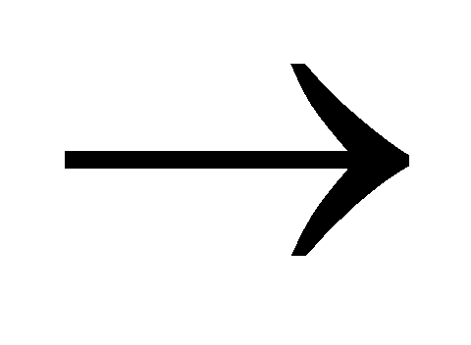AgCl (white ppt)

2Ag+ + CrO4-  Ag2 CrO4

mass of unknown = 0.1g

concentration of  AgNO**3** = 0.1M

**First titre value**

volume = 10.40cm3

n (AgNO**3** ) =[AgNO**3** ]xV(AgNO**3**)

= 0.1 x 10.40

1000

= 0.00104mol

n(Ag**i**) = n(Ag**ii**)

2

= 0.00104

2

= 5.20x10-4mol

n(Ag**i**) = n(Cl-)

= 5.20x10-4mol

m(Cl-) = n x M

= 5.20x10-4 x 35.5

**= 0.0184g**

**Second titre value**

volume = 10.50cm3

n (AgNO**3** ) =[AgNO**3** ]xV(AgNO**3**)

= 0.1 x 10.50

1000

= 0.00105mol

n(Ag**i**) = n(Ag**ii**)

2

= 0.00105

2

= 5.25x10-4mol

n(Ag**i**) = n(Cl-)

= 5.25x10-4mol

m(Cl-) = n x M

= 5.25x10-4 x 35.5

**= 0.0186g**

**Third titre value**

volume = 10.60cm3

n (AgNO**3** ) =[AgNO**3** ]xV(AgNO**3**)

= 0.1 x 10.60

1000

= 0.00106mol

n(Ag**i**) = n(Ag**ii**)

2

= 0.00106

2

= 5.30x10-4mol

n(Ag**i**) = n(Cl-)

= 5.30x10-4mol

m(Cl-) = n x M

= 5.30x10-4 x 35.5

**= 0.0188g**

**Average titre** = 10.40+10.50+10.60

3

**Mean value**  = 0.0184+0.0186+0.0188

3

= 0.0186g

**Percentage of Cl2 in sample** = mass of (Cl-) x 100%

mass of sample

= 0.0186 x 100%

0.1

= **18.6%**

**DISCUSSION**

The experiment used a redox titration to determine the weight percentage of vitamin C (ascorbic acid) in a commercial tablet.

The standard deviation and the relative standard deviation of vitamin-c are 1.586 x 10-5 and 1.76 x 10-3 respectively. This is very negligible and as such it can be said that the vitamin-c constitutes the most of the tablet. The deviation may be accounted for in the slight inaccuracy in titre values due to the undissolved solid binding material.

**CONCLUSION**

In conclusion, our data was reproducible and very precise.It was realised that 18.6% of chloride was in that sample.This is an effective way of determining chloride in a sample.This is a cheaper and faster No major sources of error were presented in this lab.

**PRECAUTIONS**

• All apparatus was rinsed with distilled before use.

• The mass of the unknownwas accurately weighed.

• The burette readings were taken from below the meniscus.

**SOURCES OF ERRORS**

* The effervescence did not entirely dissolve in the HCl before proceeding the experiment
* Too much of the indicator can affect the result of the reading

**REFERENCES**

General Chemistry by Whitten D. Peck

Vogel’s Textbook of Quantitative Analysis

Essential Chemistry by Raymond Chang

Lab. manual